**Lab 11-1 Develop a rollover application**

In this exercise, you’ll create an application with two images that change when you roll over them with the mouse.

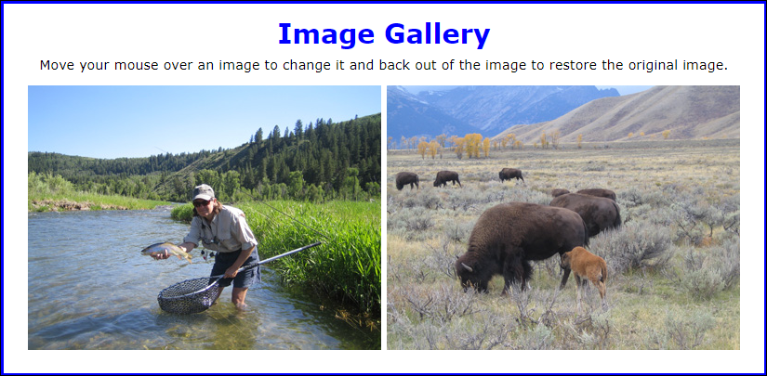

**Open, test, and review the application**

1. Use your text editor to open the files in **lab11\rollover**

2. Review the code in the index.html file and note that each li element within the ul element contains an element whose href attribute refers to one of the images used by this application. Also note that the <p> element at the bottom of the page contains two img elements with ids “image1” and “image2” whose src attributes determine the images that are currently displayed.

3. Review the code in the rollover.css file and note that it contains a style rule that keeps the ul element in the index.html file from being displayed in the browser.

4. Use Chrome to test this application. Notice that the images shown above are displayed, but nothing happens when you move your mouse over them.

**Add code to preload the images and implement the rollovers**

5. In the DOMContentLoaded event handler, add code to preload the four images used by this application.

Note: Check in the ‘Network’ tab in the developer tools to check that the images are being downloaded (do this before you click on an image).

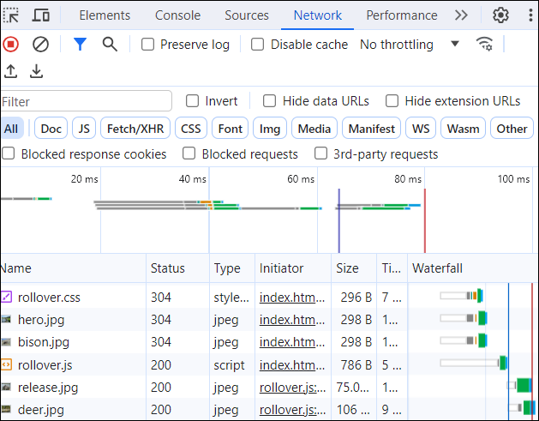

6. Add event listeners for the ***mouseover*** and ***mouseout*** events for the two image elements that are displayed on the page.

* The image element with id “image1” should display the release.jpg image when the mouse is over it and the hero.jpg image otherwise.
* The image element with id “image2” should display the deer.jpg image when the mouse is over it and the bison.jpg image otherwise.

7. Test the application to be sure that the rollovers/transitions are working and that the correct images are being displayed.

**Lab 11-2 Enhance the Slide Show application**

In this exercise, you’ll enhance the Slide Show application by adding buttons to start and pause the slide show.

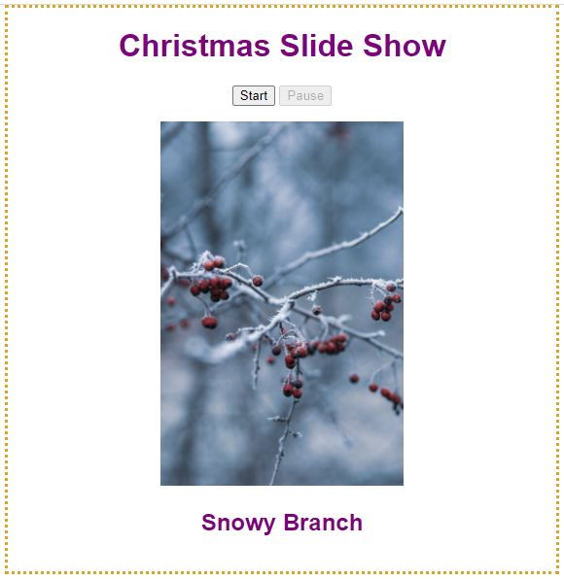

**Open and test the application**

1. Open the HTML and JavaScript files in: lab11\slide_show

2. Use Chrome to test this application. Notice that the slideshow isn’t running, the Pause button is disabled, and nothing happens when you click on the Start button.

3. Review the code in the index.html file, and notice that the disabled attribute of the Pause button is set to “true”. That makes sense because the user shouldn’t be able to click this button if the slide show isn’t running.

4. Review the code in the slide_show.js file and note that the code for running the slide show is coded in a function named runSlideShow(). Also note that some of the variables and constants are global so they can be accessed by the runSlideShow() function and the DOMContentLoaded() event handler.

5. Within the DOMContentLoaded() event handler, add code to the click event handler of the Start button that creates a timer that runs the slide show and changes the slide every 2 seconds. In addition, add code that disables the Start button and enables the Pause button. To disable a button, you can set its disabled attribute to true. To enable a button, you can set its disabled attribute to false.

6. Test the application again and click the Start button to make sure the slide show is working. Notice that there’s a delay of 2 seconds before the next slide is displayed.

7. Add code to the click event handler of the Start button that calls the runSlideShow() function before the timer is started. Then, test the application again to see that the next slide is displayed immediately when the Start button is clicked. Add code to pause the slide show when the Pause button is clicked

8. Add code to the click event handler of the Pause button that cancels the timer. In addition, add code that enables the Start button and disables the Pause button.

9. Test the application again, click the Start button to start the slide show, and then click the Pause button to pause the slide show. Click the Start button again to restart the slide show.